FINANCIAL REPORTING AND FINANCIAL ANALYSIS USING POWER BI
- Profit and loss account
- Balance sheet
- Cash flow statement
- Statement of changes in equity
- Profitability ratio
- Liquidity ratio
- Risk management ratio
The dataset present in datasets folder, In GL, the territory key has information about territory which is a separate, all information related to territory not present here because we don’t wanna overpopulate that file.
Data model m table k kuch columns pr automatically kuch data categories select I hoti hn, e.g: kisi bhi date column ko pakro, us column k saath date ka icon bna ho ga, similarly, symmation ∑ ka icon aya hua hota h, agr index ya kisi or column k upper y symbol aya jisy hm sum nhi krna chahty, then data model k andr rehty huy hi select that column, go to properties (window present on left side), then go to advanced and data category m ja kr None kr do,, also some some categories when needed
- 1st we are calculating the amount generated by sales, ab jo aamount column m ammounts likhi hn bs unho ko hi sum nhi kr dena pakar kr, q k saari amount sales s generate nhi hui, chart_of_account table m jao or class, subclass, subclass2 m ja kr dekho to pta chly ga k sales k saath saath or kiittnii classes hn jin s amount mili ya gai
- Matrix m ja kr columns m just year daalny ki Bijay poori date ka column daal do to hierarchy create ho gi, yani arrows ay gy matrix k upper, jis s aap dril up ka dril down bhi kr skty to and hierarchy m upper neechy bhi ja skty ho to move to quarters, months, days etc etc . NOW we have 3 years, then hierarchy m neechy jany s we will move to quarters and it will give the sum of Quarter 1 of 2018+2019+2020, similarly for months: will give the sum of amount of all three years in each month,e.g for January: 2018 ki january, 2019 ki january, 2020 ki January ki amount, yani y teeno ammounts plus ho kr show ho gi January m, similarly for feb and so on, if we move further further to days, the esy hi teeno years ki un un days ko amount plus hogi and then show ho gi ,,, similarly we can drill down, yani if we have on years and we want just year 2020 ki hi quarters ki value, or phir in quarters k andr agy months ki value etc show hon to drill ko on kr k just us year pr click kr do and you will get quarters, then kisi ek quarter pr click kr do then you will get months of that quarter and so on
- Ab isi matrix ko select kr k line chart select kr do and you will get all that information in the form of graph, isi graph k legend m puri ki puri date daal do and click on ‘DATE HEIRARCHY’ from legend’s date dropdown and you will get all the information of three years altogether, like following:

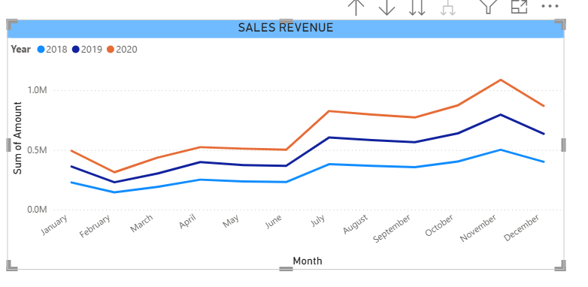

PROFIT AND LOSS STATEMENT:

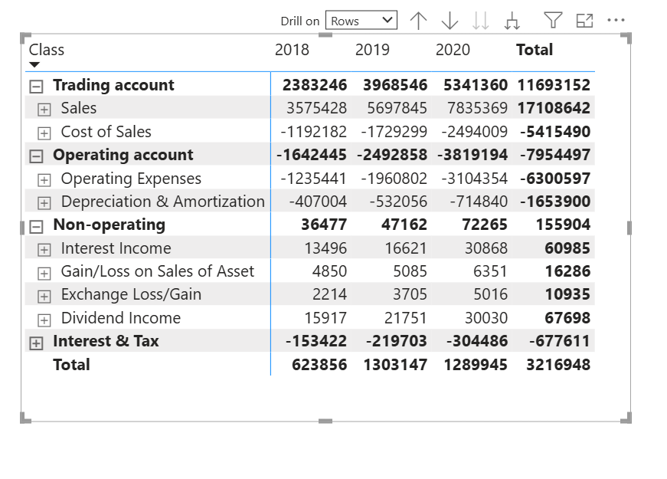
y just profilt and loss ka chart h, filter m ja kr just profit and loss select kia hua h, sab s phly sort to just top right corner k 3 dots pr kr k ho gya, then 2nd sort jo k sub-class k andr krna tha, us k liye jo y dropdown ka symbol sa a rha h "Class" column k uper us k zarye krna h, or is k liye class (e.g: trading account) k ander jo subclasses mention hn vo show hi rhi hon, yani class (e.g: trading account) k saath minus ka sign ho yani k y khula hua h, them Class column pr double click krna h, then y subclasses sort ho jayn gi, top right corner k 3 dots pr click kr k sort m ja kr check bhi kr lo k ab classes and subclasses dono sort hn
- Ab sales and cost of sales and all others have exact operators mention hn, sales k saath kuch nhi yani + and cose of sales k saath minus ka, to jab total kryn gy to hmy netprofit khud hi mil jay ga ,, yani exoenses already negative hn, we don’t need extra effort
- Add a slicer for each country and you will get the net profit with respect to each country

Until now: we have created profit and loss statement and now we will create net profit, gross profit, operating profit, profit before interest and tax.
Gross profit: revenue – cost of good sold
Yani jo revenue generate hua us m s just manufacturing cost (cost of making, cost of raw materials etc) minus kia just to vo gross profit mily ga,, ab TRADING ACCOUNT ki total amount ko dekhy to y actually gross proft hi h q k is m sales s jo amount mili us m s cost of sales ko minus kia hua h
End m jo overall amount hmy mil rhi h vo net profit h q k us m s taxes, labour cost, marketing cost (e.g: advertisement) etc etc sab ko minus kr k amount mili h
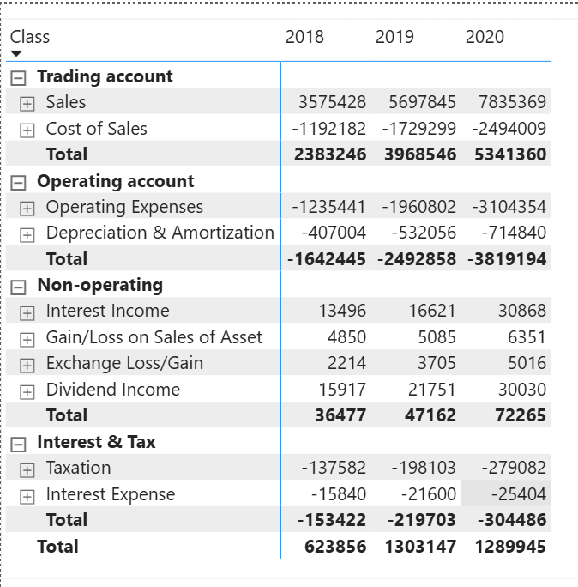
Now we want k isi matrix m hi TRADING ACCOUNT ki TOTAL amount h us ko rename kr k GROSS PROFIT kr dun and end valy total ko rename kr k NET PROFIT kr dun, but it is not possible here, so we will separately for each type of profit
DATASET m bhi CHART OF ACCOUNTS table m ja kr reports column m PROFIT AND LOSS h and agy class column m explain bhi kia hua h k kha kha s y profit ya loss a rha h, hmy yhan y idea ho ga k hm ki skis trah ka profit nikaal skty hn, yani TRADING ACCOUNT column k agy sales and cose of sales likha hua h, yhan s bhi pta lag rha h k hm gross profit nikal skty and we can calculate other profits as well, just focus of properly on dataset before starting.
Now we want k isi matrix m hi TRADING ACCOUNT ki TOTAL amount h us ko rename kr k GROSS PROFIT kr dun and end valy total ko rename kr k NET PROFIT kr dun, but it is not possible here, so we will separately for each type of profit
- GROSS PROFIT:
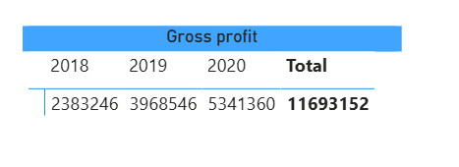
Simply create a matrix, values m amount daal di, column m year daal dia and filter m ja kr filter on this visual m ja kr CLASS column daal kr trading amount ko select kr dia, yani just trading amount ki value hi calulate honq k is k andr hmary pas (sales – cost of sales h)
- OPERATING PROFIT:
Now we will calculate operating profit, ab operating account m dekhy to just (expenses + Depreciation and amortization (y bhi expenses hi hn assets leny k )) hn, ab ofcourse esa to h nhi k hm in sab expenses ko plus kryn or khy k y hmara operating profit h (koi pagal hi ho ga jo esy kry ga), we will subtract all these expenses from our gross profit to get operating profit

Is k liye esa hi matrix bnay gy but filter m hm trading account and operating account dono ko daal den gy (yani in sab ki values ko plus kr do, ab sales vali value k andr s saary other values such as cost of sales and other expenses minus hon gy , yhan minus ka sign already lga hua h expenses k saath so we don’t need to have further calculation)

- PROFIT BEFORE TAX AND INTEREST (PBIT):
Now we will also add non-operating expenses in the filter and get values, ab saary expenses add ho chuky hn bs taxes rehty hn, to hm n is liye y heading use kr li, k saary expenses nikal kr jo hmy value mili and jo tax hm n dia, us s phly phly tk hmara y profit chal rhi thi

- Net profit:
Matalb revenue m s saary expenses and tax ko minus kr k jo amount mili

Revenue m s COGS (manufacturing cost, cost of raw materials etc) ko minus krny s GROSS PROFIT mila, gross profit m s just operating expenses ko minus krny s operating profit mila (operating profit also called EBIT yani EARNING BEFORE INTEREST AND TAX), is EBIT m s interest and tax and other non operating expenses minus krny s NET PROFIT mila
Operating expenses m amortization and depreciation or is k ilava kuch or expenses bhi aty hn,
Operating expenses m s A & D ko chor kr baki k expenses ko lets suppose hm X bolty hn,
gross profit m s just X ko nikal dia to hmy EBITDA (earning before interest, tax, depreciation and amortization) mila, yani EBITDA wo profit hai jisme abhi tak interest, tax, depreciation aur amortization and other non-operating expenses deduct nahi kiye gaye., yani EBITDA ki amount m s just A & D ki minus krny s hmy EBIT mily ga phir EBIT m s tax and interest and other non operating expenses ko minus krny s NET PROFIT mily ga
EBIT me operating expenses already deduct ho chuke hote hain, isi EBIT k peso k andr just Amortisation and Depreciation ko vapis daalny s hmy EBITDA mila (EBIT + A&D EBITDA), yani ab EBITDA k andr tax and interest and other non-operating expenses or amortization and depreciation k pesy mojood hn, y pesy deduct nhi kiye gay

Revenue – COGS = Gross Profit
Gross Profit – Operating Expenses (including D&A) = EBIT
EBIT – non-operating expenses (othr than interest and tax) = PBT (PBT m s abhi tk interst and tax k pesy deduct nhi huy huy)
PBT – Interest and Tax = Net profit (yani overall EBIT – Interest – Tax – other non-operating expenses = Net Profit)
OR
EBIT + D&A = EBITDA

Revenue – COGS = Gross Profit – Operating Expenses (including D&A) = EBIT ± Non-operating items = Profit Before Tax – Tax = Net Profit

PBT (profit before tax) m s sara kuch yani operating expenses and other non operating expenses nikly huy hn bs interest and tax nhi nikla hua, yani in peso m s bs interest and tax k pesy nikalny s hmy net profit mil jay ga

- Interest and tax is generally considered a part of non-operating expenses , but sometimes they can be different , yhan m n non operating ko interest and tas s almost different hi consider kia h
The yellow ones are actually the lecture from udemy , but in reality and in most cases, EBIT AND PBIT are same and the different thing is PBT (Profit before TAX), the complete process is that revenue – COGS = Gross profit – operating expenses = PBIT/EBIT ± non-operating items − interest = PBT (Profit before tax) – tax = Net profit
INTRODUCTON TO DAX HERE:
ROI (return on investment), Gross profit margin, net profit margin, return on capital employed calculated only using DAX.
If we wanna calculate gross profit margin, we will divide gross profit by sales, and there is no any way other than DAX to do that. With DAX, the opportunities become endless and we can anything we want
- GROSS PROFIT: use CALCULATE function to calculate gross profit using DAX and this is highly used function, almost 90% financial analysis made with this function:
gross_profit = CALCULATE(SUM(GL[Amount]),'Chart of Accounts'[Class]= "Trading account", 'Calendar'[Year] = 2019)

- PBIT = CALCULATE(SUM(GL[Amount]), 'Chart of Accounts'[Class] IN {"Trading account", "Operating account", "Non-operating"})
THE BEST WAY IS “IN”, because OR 2 s ziada conditions accept nhi krti. Efficient way IN h

- I have calculated net profit, gross profit, EBIT, EBITDA, PBIT etc etc using DAX, check out the formulaes from the analysis file, the fornulas are easy and staright forward.
NET PROFIT AND GROSS PROFIT MARGIN:
Net profit margin tells us how much profit a company earns from every $1 of sales.
For example, if the net profit margin is 20%, it means that out of every $100 of revenue, the company keeps $20 as profit after paying all expenses — including manufacturing cost, operating expenses, non-operating expenses, interest, and tax.
Similarly, gross profit margin tells us how much profit the company earns from its sales after deducting only COGS (Cost of Goods Sold).
For example, if the gross profit margin is 20%, it means that out of every $100 of revenue, $20 remains after covering manufacturing costs. This $20 is then used to cover operating expenses, interest, tax, etc.
What High and Low Margins Mean:
High net profit margin means:
Better cost control + Better pricing power + Efficient operations
Low net profit margin means:
High overall expenses or weak pricing
High gross profit margin means:
Lower manufacturing cost relative to selling price + Strong pricing power
Low gross profit margin means:
High manufacturing cost or product sold at a lower price due to competition
Working With FISCAL/FINANCIAL Year that is different from Calender Year:
Calender year start from January and ends at December, but financial year starts from July to 30th June and sometimes, it starts from april to 31st march, (depending on different countries, in eurape, financial and calender year are same, it start from January to December),
Means according to financial or fiscal year, the fiscal month of January is 7 (we are considering Pakistani fiscal/financial year that start from 1st July to 30th June)
To handle the calender year and fiscal year, we can do it in excel and in power BI as well, for POWER BI, we created a new file named DATE HANDLING , isi C drive k folder m hi ,,
DIFFERENCE BETWEEN CALENDER() AND CALENDERAUTO()
Calenderauto() s ek new table bny ga and is dataset m jitni bhi dates hn us ki base pr dates daali jayn gi, is table k dates couimn m, or is column m vo saari dates hon gi jo k us dataset m mojood hn,
But of there is no dataset, ya dataset m dates kisi bhi table m nhi hn to we can use CALENDER() function and manually pass dates like that: Table = CALENDAR(DATE(2018,01,01), DATE(2020, 01,01)),, This is calender year of course! You can give start months and end months and days according to financial year, but i am starting from scratch, this step can be different but remaining steps are same.
We have created fiscal year, fiscal month, fiscal quater etc using different DAX firmulaes mentioned in analysis file, now we will add the fiscal year and all others into hierarchy, we have to add them manually , TABLE VIEW m hi rehty huy right side pr jhan saary columns mentioned hn vhan date k column k upper right click kr k add to hierarchy pr click kr do and saary other things such as months etc ko bhi isi hierarchy m daal do, When we have a column in atable and is columnki datatype date h, Model view m bhi jak r us ki formatting m date mention h to power BI automaticaaly us ki hierarchy create kr deta h, hierarchy ka faida y hota h k hm easily drill down etc kr skty hn, e.g: when we are using matrix and line chart etc etc

Credit and Debit Concept:
🌟 First: What Are These 5 Accounts?
Assets, expenses, equity, revenue, liability
Every business activity fits into one of these 5 boxes:
1️⃣ Assets
👉 What the company owns
Examples:
- Cash
- Bank money
- Building
- Machines
- Inventory
Simple meaning:
Things the company has.

2️⃣ Liabilities
👉 What the company owes to others
Examples:
- Loan from bank
- Money to suppliers
- Unpaid bills
Simple meaning:
Money the company must pay later.

3️⃣ Equity
👉 Owner’s money in the business
Example:
- Capital invested by owner
- Profit kept in business
Simple meaning:
Owner’s share in the company.

4️⃣ Revenue
👉 Money the company earns
Examples:
- Sales
- Service income
Simple meaning:
Money coming in from selling products or services.

5️⃣ Expenses
👉 Money the company spends to run the business
Examples:
- Rent
- Salary
- Electricity
- Marketing
Simple meaning:
Money going out to operate the business.

🌟 Now Let’s Make It SUPER Simple
Think of a business like this:
You open a small shop.
- You put money → Equity
- You buy goods → Asset (inventory)
- You take loan → Liability
- You sell goods → Revenue
- You pay rent → Expense
That’s it. Only 5 types.

🌟 Now What Is Debit and Credit? (Very Easy Version)
Debit and Credit are just left and right sides of accounting.
They do NOT mean good or bad.
They do NOT always mean receive or pay.
They just tell us which side increases or decreases.

🧠 Golden Rule (Very Easy Trick)
Debit increases:
✔ Assets
✔ Expenses
Credit increases:
✔ Revenue
✔ Liabilities
✔ Equity
That’s it. Just remember this.
Debit and credit do not simply mean decrease or increase; their effect depends on the type of account. In accounting, everything follows the equation Assets = Liabilities + Equity, and every transaction has both a debit and a credit to keep this equation balanced. When a credit increases, it does not mean that a debit decreases; instead, it means that another account is debited. For example, if a company takes a loan, cash (an asset) increases with a debit and the loan (a liability) increases with a credit, so both sides increase. Similarly, when paying an expense, the expense increases with a debit and cash (an asset) decreases with a credit. So, increases in liabilities or equity do not always mean assets or expenses decrease—it depends on the transaction. The key idea is that debit shows where value is going, and credit shows where value is coming from, and both work together to keep the accounts balanced.

🌟 Now What Is EBIT? (Very Simple)
EBIT = Earnings Before Interest and Tax
It means:
👉 Profit after expenses
👉 But before interest and tax
Simple formula:
Revenue
– Cost
– Operating expenses
= EBIT
That’s it.

🌟 Very Very Simple Summary
Assets → What we have
Liabilities → What we owe
Equity → Owner’s money
Revenue → Money earned
Expenses → Money spent
Debit increases Assets & Expenses (DExA means Debit increase Expenses and assets)
Credit increases Revenue, Liabilities & Equity
Making a long story short:
There are 5 types of accounts in a business:
- Assets (cash, bank balance, inventory, machines, company building)
- Expenses (labor cost, electricity bills, etc.)
- Revenue
- Liabilities (bank loans, debts, etc.)
- Equity (the amount you invested)
These five accounts fall into two categories: Debit and Credit.
- If the account is Debit-based, it means that Assets or Expenses increase with a Debit entry.
- If the account is Credit-based, it means that Revenue, Liabilities, or Equity increase with a Credit entry.
The General Ledger (GL) records all transactions of a company. In the GL, amounts may appear as positive or negative depending on the system:
- In some systems, like Power BI:
  - Positive sign = Credit entry → Revenue increased, or a Credit-type account like Liability or Equity increased.
  - Negative sign = Debit entry → Assets increased, or an Expense account increased.
- In other systems, Debit may be shown as positive and Credit as negative.
These positive and negative signs are just directions.
- Positive is not “good,” negative is not “bad.”
- They are shown this way to make calculations easier.
Finally:
- Credit always increases Credit-type accounts and decreases Debit-type accounts.
- Debit always increases Debit-type accounts and decreases Credit-type accounts.
making long story short, there are 5 different types of accounts within a business: Assets (such as cash, bank balance, inventory, machines, company building), expenses (such as labour cost, electricity bills etc etc), Revebue, liability( such as bank loan, debts etc) and Equity (jo amount ap n invest ki hui h),, y paancho accunts 2 categories k under aty hn: CREDIT and DEBIT,,, If the category is DEBIT means expenses or assets of the company incrreases and if it is CREDIT means revenue, ya liability ya equity increase hui h,, GL (General ledger: jis k andr company ki saari transactions ka record hota h) us m amount k saath sometimes positive and sometimes negative ka sign hota h, According to some systems such as Power BI, positive sign means y amount credit k under ati h, yani y amount ya to vo revenue h jo generate hua h, ya koi or credit type account increase hua h such as liabilty ya equity,, similarly, agr amount k saath negative likha hua h, yani k y amount debit type accounts k under ati h, y amount ya to assets m izafa ki amount h ya y amount expense h koi,, ,,,,,, Kisi kisis systme m debit k saath positive and credit k saath negative likha hota h,, these positive and negative signs are just directions, yhan positive sign acha and negative sign bura nhi h, y just calculation ko easy krny k liye show hoti h, credit hamesha credit based account ko increase krty hn and debit based account ko decrease krty hn and vise virsa with debit
- IF EXPENSES INCREASE THEN IT IS DEBITED AND IF EXPENSES DECREASE THEN IT IS CREDITED, MEANS DEBITED M EXPENSES AND ASSETS INCREASE HITY HN TO YANI CREDITED M Y DONO DECREASE HOTY HN , SAME IS THE CASE WITH CREDITED, CREDIT M JO CHEEZY (REVENUE, LIABILITIES AND EQUITY) INCREASE HOTI H, DEBITED M VO DECREASE HOTY HN

- Account m amount -ve m h, yani ya to liability, equity or revenue increase hua h ya assets and expenditures decrease hua h, yhan account_key 135 h, 135 pr ja kr dekho to chartr of account m to liability and owner’s equity likha h, yani y cheezy increase hui h, is liye -ve sign aya
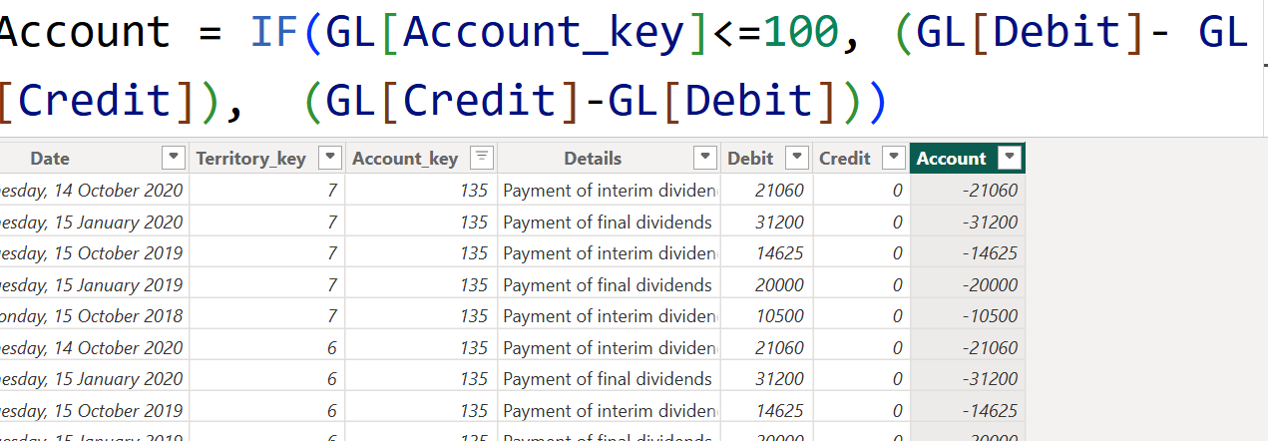

Foolproof sorting system for income statement and balance sheet:
In profit and loss statement and in balance sheet, the matrix visual only sort alphabetically in power BI, but we want to sort like k sab s phly sales ay, then cost of sales, then operating expenses, then interest & tax and then net profit but power BI don’t do this, moreover, we cannot do multi level sortinf in power BI e.g: if we have class and subclass and sorting on the basis of class will ok but when we try to sort on the baisis of sub-class, to subclass vala to alphabetically sort ho jay ga but class-level sorting disturb ho jay gi, moreover, isi liye hm ek foolproof sorting system develop krty hn manually
Hm y system bnaty kesy hn? Hm dataset m hi hr ek ek level pr ek new column bnaty hn and us column m numbers lgaty hn e.g: CLASS column m hmary pas Trading account , operating account, non-operating, interest& tax vali rows hn, hm ek new column bnay gy ‘CLASS-SORT-LEVEL’ jis m trading accountko number 1, operating account ko number 2, non operaying ko 3 and so on den gy,, isi trah cost of sales m bhi sales ko 1, cost of sales ko 2, operating expenses ko 3, non-operating ko 4 and so on,,, isi trah hm hr column (yani hr level) pr ek new column bnay gy and numbers den gy, then hm power BI m a kr us specific column pr e.g: class column pr click kr k SORT BY pr click kr ‘CLASS-SORT-LEVEL pr click kr den gy and is trah y vala colymn is k according sort ho gya, isi trah hm saaryy column ko sort kryn gy and ab jab hm matrix bnay gy to automatically sara kuch sorted ho ga,,,, actually hm just P&L related values ko hi sort nhi krty, hm balance sheet valo ko bhi krty, e.g: in class column , we have actually assets, liabilities and opwners equity, then trading account, operatinmg and so on, we will start by giving assets to number 1, then liabilities and owners equity to number 2 then trading account to number 3 and so on,,,, bht dfa dataset m esy ho ga k values khud hi tarteeb s nhi hun gi e.g: dataset m khud hi non operating vali phly then operating then tax and then trading account etc , kuch is trah s ya koi or tarteen a rhi ho gi, hmy phir bhi tarteeb khud s lgani ho gi, e.g: trading ko phly rkhna ho ga then operaying and then nonoperating etc etc
BALANCE SHEET:
When we create a matrix in power BI, if in columns portion, we have years (2018, 2019, 2020) then values m agr hm amount daalty hn to automatically filter apply hota h or hr year ki respective amount ati h, matlab 2018 m 1st jan 2018 to 31 dec 2018 tk ki amount ati h , similarly 2019 m apni and 2020 m apni,, but we want k hr year m start s le kr us respective year tk ki amount show ho e.g: 2019 m 1st jan 2018 s le kr 31 dec 2019 tk ki amount, 2020 m 1st jan 2018 s le kr 31 dec 2020 tk ki amount show ho,, yani hmy matrix k default behaviour ko override krna h, we will do it using following measure: min_date_across = CALCULATE([min_date], FILTER((ALL('Calendar'[Date].[Date])), 'Calendar'[Date].[Date]))
ALL() will remove any filter that will apply automatically by power BI into any matrix, visual etc etc
Filter() function phly ek virtual table bnay ga and us table m s minimum date ko get kia jay ga,, agr hm y formula use krty hn: min_date_across = CALCULATE([min_date], ALL('Calendar'[Date].[Date])),, to yhan pr ALL() saary k saary filters hi khatam kr de ga, yani matrix k hr value m hmy date 1st jan 2018 s le kr 31 dec 2020 tk ka data de gi, but hmy hr value 1st jan 2018 s le kr us respenctive year tk show krni h, is liye filter lgana zruri h ,,, and we have to use filter when we have to get commulative logic, etc

A balance sheet is like a financial snapshot of a company at a specific point in time. It tells you what the company owns, owes, and the owners’ stake in the business.
A balance sheet is divided into 3 main parts: Liabilities, owner’s equity and assets.
Assets = Liabilities + equity (always assets ki amount equal ho gi us amount k jo hm liabilities and owner’s equity ko + kr k get kryn gy,, pie chart m bhi in dono ko rkho to equal equal ay ga )
Balance sheet tells you:
• Financial position – How strong the company is in terms of assets and debts.
• Liquidity – Can the company pay short-term obligations? (Check current assets vs current liabilities).
• Solvency – Can the company meet long-term debts?
• Owner’s value – How much of the business belongs to the owners vs creditors.
• Trends – By comparing balance sheets across years, you see growth, asset increases, or rising debts.
In pie chart, the value that we place in the legend, the detail’s value provide more details to the value of the legend, e.g: in asaan bhasha: legend m subclass (liability, assets, equity) daal dia, and details m sublcass2 daal dia, to liability m jo jo maseed cheezy thi jo k subclass2 m show ho rhi thi such as current liabilities and long term liabilities, y dono isi liability k color k andr rehty huy hi show ho gi beech m bs ek separate white line a jay gi, same isi trah ka concept treemap m bhi h,
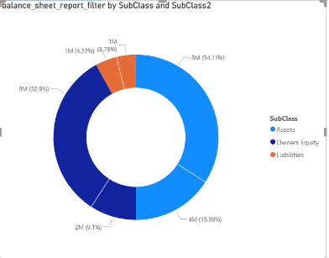

As you can see k liabilities k orange color m rehty huy hi maseed currect liabilities and long tern liabilities jo k sub-class2 column m mention h show ho rha h, q k hm n details m subclass2 daala hua h
Liquidity:
Liquidity indicates how easily an asset can be converted into cash, because cash ko hm immediately use kr skty hn.Following assets can be converted into cash quickly and easily
Cash (highest liquidity), bank balance (high liquidity), marketable securities such as treasury bills (high liquidity because can be sold within minutes and we can get cash), customer returnables (medium liquidity),,,,,, company building, land, machines, inventory etc have low liquidity because these things take time to convert into cash.
-- CONCEPTUALLY hm y baat keh skty hn k there are 2 types of assets : liquid and non liguid assets but finance m hm y terms use nhi krty, hm yhi kehty hn k highly liquid assets (which are current assets ) and less liquid assets (which are long term assets),,, inventory is a current assets but it is slow as compared to other current assets in terms of converting to cash.
CURRENT RATIO:
Determines whether a company can pay its short term liabilities using short term assets.
CURRENT RATIO = CURRENT ASSETS/CURRENT LIABILITIES
If ratio = 1, means company have equal assets and liabilities and just itna hi pesa h k vo bs liabilities ko cover kr skti h
If ratio> 1, means company have more assets compared to liabilities and can pay liabilities easily, means company is financially safe.
If ratio <1 , means company cannot pay current liabilities such as current debts and is in bad condition financially, indicate liquidity problems.
Very high (like 4 or 5) → Might mean inefficient use of assets (too much idle cash or inventory)
Quick RATIO/Acid test ratio:
Tells whether a company can pay its current liabilities using only high liquid assets, now Inventory is not a high liquid asset, so we are removing it and then dividing the value with current liability, means bs yhi check krna h k kia high liquid assets k zrye hm apni liability pay kr slty hn ya nhi,, this ratio is more strict as compared to current ratio.
Quick ratio = (Current assets – inventory) / current liabilities
Quick Ratio > 1
Company can pay short-term obligations without selling inventory.
Quick Ratio = 1
Company has exactly enough liquid assets.
Quick Ratio < 1
Company may struggle to pay debts quickly.
Gearing ratio:
It is a relationship between debt and equity, it tells how much of company’s financing comes from debt compared to owner’s equity, means k company debts pr kitni dependent h
Gearing ratio = debt / owner’s equity
High gearing ratio means company mostly dependent on debts and low means ziada tr finances equity pr dependent hn,, bank valy loan deny s phly gearing ratio ko dekhty hn k kia y loan repay krny k kabil h ya nhi, investors bhi gearing ratio ko hi dekhty hn to check long term financial stabitlity.
Assets turnover: (WILL DO IT LATER !!!!!!!!!!!!!!!!!!!!!!!!!!!!!!!!!!!)
Shows how efficiently company uses its assets to generate sales or revenue.
Assets turnover = sales or revenue / assets
Matlab hr 1$ assets pr company n kitna revenue generate kia
High value indicates that a company is using assets efficiently,, if a company have sales of 50,000 and assets of 25,000 then assets turnover = 2, means every 1$ of assets, the company is generating 2$ of revenue.
Return over capital employed (ROCE):
Tells how efficiently a company uses its capital to generate profit.
Means 1$ jo company n invest kia us m s kitna profit generate hua
ROCE = Operating profit /capital employed
You already know operating profit and capital employed is the total money used to run the businesss and it can be (equity + long-term debts) or (assets – liabilities ), we will use first formula
Conceptualy it combines 2 things: profit margin x assets turnover and we can increase ROCE by increasing profit margin or efficiently using assets.
meas if a company spends 1$ of its capital employed and ROCE answer is 2, means hr 1$ invest krny pr company is getting 2 $ in return, this 2$ is profit actually
- We have calculated capital employed commulative but operating profit separate because We do not use cumulative operating profit because profit belongs to a specific year. Each year has its own profit. However, assets and liabilities represent the total position of the company at a certain time. For example, if the company had 10 debt in 2018 and took 5 more in 2019, then the total debt in 2019 becomes 15. That is why assets and liabilities are considered cumulative values.,, same case implemented to different rations such as current ratio, quick ratio, gearing ratio etc etc k hm n commulative q liye ,,,, JO CHEEZ P & L KI H VO CUMMULATIVE NHI AY GI, JO CHEEZ BALANCE SHEET KI H COMMULATIVE AY GI
Return on Equity (ROE):
Hr doller jo stakeholder n invest kia, us pr kitna profit mila,, this is different from ROCE as ROCE m hm total capital employed (equity +longterm debt) ki base proprofoit dekha jata h k kitna total capital profit generate kr rha h but yhan ROE m just stakeholder ki investement kode kha jata h
Ratio | Question
ROCE | How well total capital generates profit?
ROE | How well owners' money generates profit?

ROE = Net profit / owner’s equity
Net profit hr saal ka apna apna hota h but owner’s equity commulative leni h
Interest cover:
How easily a company can pay its interests, yhan hm dekhty hn k jo profit us n kmaya vo itna h k vo company k interests ko pay kr sky, e.g: if profit before interst and tax (PBIT) is 10,000 and interest is 2000, then interest cover = 10,000/2000, means company n jitna interest pay krna h us s vo 5 times ziada kma rhi, yani easily interest pay kr skti h, y ratio bhi dekhi jati h jab bank valy loan deny lagty hn k itna interest is loan pr h to kia company chuka pay gi y qeemat ya nhi
Interest cover = PBIT / Interest expense
We will use PBIT , instead of PBI (profit before interest) because tax is cutted after paying interests, if a company just earn enough money k bs interest pay ho sky and thora bht upper profit kma le, lekin vo profit itna nah o k tax pay ho skty to yani company financially stable nhi h
Interest Cover should ideally be comfortably above 1 (typically 3–5 or higher).
Receivable collection period:
Yani kitny dino m customer vo money jo us n company ko pay krni thi, return kry ga.
Credit sales s murad vo sales hn jis m hm customer ko kuch sale krty hn and customer saari ki saari money akathi pay nhi krta, vo baad m thori thori kr k pay klrta rehta h
Recievable Collection Period = (Trade Receivable Balance /credit sales) * 365 (yhan just trade vali ay gi, jo cash s ho gi vo nhi ani)
Receibvale balance yani k kitni total amount h jo k customers n abhi pay krni h, sales yani total kitni credit sales ho chuki h
e.g: 20,000/100,000 * 365 = 73 days (yani 100,000$ ki vo sales thi jo k hm credit sales ki, or 20,000 vo amount h jo abhi tk customers n pay krni h ,, yani us n 80,000 pay kr dia hua h or abhi mazeed 20,000 krna h and vo 20,000 vo almost on average 73 days m kry ga)
• 30 days → very good collection
• 60–90 days → normal in many industries
• 120+ days → risky (slow payments)
Payable Payment Period (Payables Days):
How much time a company takes to pay to purchaser.
Payable days = Trade payable amount / total credit purchases * 365
Trade Payables = money the company still owes to suppliers
Credit Purchases = purchases made on credit,,, apny dataset m hm n yhan pr cost of sales lia h
(yani vo total purchases jo us n credit pr ki thi , credit yani saary pesy us time akathy nhi diye(credit purchases) us m s kitni amount maseed deni h (trade payables))
A higher payable period is not always bad. Because if a company delays payments within agreed credit terms, it can use that cash longer for business operations.
Example:
- Supplier allows 60 days credit
- Company pays in 55 days
This is good cash management. But if the company pays after 120 days when terms are 60, it may indicate cash flow problems.
Inventory turnover period:
Means how much time (days on average) inventory stays in the business before being sold or we can also say in how fast a company convert inventory into sales.
Inventory turnover period = inventory / cost of sales * 365
Inventory turnover period = average inventory / cost of sales * 365

HOW TO USE DRILL THROUGH:
If we want k hm kisi table ki kisi value pr click kryn e.g: we have a matrix with columns have years and rows as class, subclass, subclass2 etc and we want k class (operating account) ki subclass (operating expenses) ki subclass2 (advertisement) s related saari information chahye , yani kuch esa ho k hm us pr click kryn and us s related 1 page open ho jis pr sara ho, similarly, hm kisi bhi parameter pr click kryn and page open ho and us pr us parameter s related saari information ho,,
Hm ek page bnay gy, lets say its name as A, jis pr hm bhhtt s tables, graphs, slicers etc etc lga den gy and us page pr right side pr drill through k option m cross report ko on kr k vo vo columns daal den gy jin pr hm chahty hn k click kia jay to y A vala page open ho, and is A valy m usi s related information ho,, ab hm kisi or page pr jayn gy and un columns m s (vo columns jo hm cross report on kr k daaly hn) kisi column or right click kr k drill through m ja kr A ko click kryn gy to A open ho ga jis m saari info just us column s related hi ho gi
Now, us A pr s us column ka filter khatam krny k liye cross report m jo columns daaly th un pr hover kro to erasor k Nishan pr click kr k khatam kr do, y erasor ka nishan vesa hi h jesy hm slicer ki selection clear krny k liye use krty
Section 10: Trial Balance Report:
A Trial Balance is a simple report that shows the total balance of every account in a company at a specific date.

It is basically a summary of the General Ledger.
In the General Ledger, we have all the individual transactions (each sale, expense, payment, etc.).
The Trial Balance collects those transactions and shows only the final balance of each account. ,, e.g: chart of account m jo saari subclasses mention thi, such as assets, liabilities, owners equity, sales etc etc, and In the General Ledger, each account key has many transaction amounts. In a trial balance, we summarize all those transactions and show one total balance for each account, so we can quickly see all accounts and their balances.. ,, y just accounts and their balance tk ki limited nhi h, we can create trial balance report even with report level, class level, subclass elevel etc etc and then can also add slicer for country and year as well,,,,, is it correct
In our trail balance we have created following report:
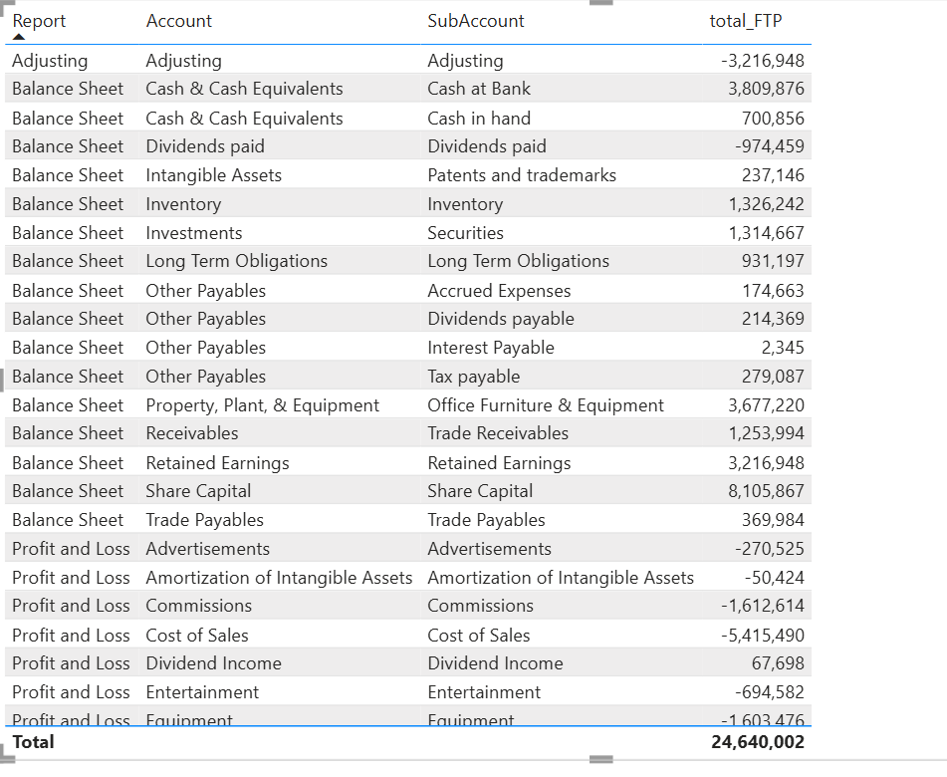
But the issue is that k FTP value (which is just the sum of total amount) is ok for p and L but not for balance sheet because balace sheet need commulative value means it need total to date, so will create the following measure and put that in the report.

total_value_alternate = COALESCE(
CALCULATE([total_to_date], 'Chart of Accounts'[Report] = "Balance Sheet"),
CALCULATE([total_FTP], 'Chart of Accounts'[Report] = "Profit and Loss")
)
Coalesce is used when we have to use 2 measures together. This formuyal will give an error actually because of total_to_date k andr hm n total_to_date = CALCULATE(SUM(GL[Amount]), DATESBETWEEN('Calendar'[Date].[Date], [min_date_across], [max_date])) y formula lgaya hua h and DATE.DATE issue create kr rha h, is liye hm n maseed .[Date] ko khatam krna h, yhan s bhi or min date across and max date k formula s bhi, yani hr jga s hm n date.date vali doosri date ko htana h, then coalscene vala formula correct value return kry ga
Lekin m n y formula khud s likha h and y correct result de rha h: total_value = IF( [balance_sheet_report_filter], [total_to_date], IF( [P_and_L_report_filter] , [total_FTP]))
Whereas: balance_sheet_report_filter = CALCULATE(SUM(GL[Amount]), 'Chart of Accounts'[Report]="Balance Sheet")
And P_and_L_report_filter = CALCULATE(SUM(GL[Amount]), 'Chart of Accounts'[Report]="Profit and Loss")

MY FORMULA IS CORRECT BUT NOT RELIABLE , BETTER TO USE : total_value =
IF(
SELECTEDVALUE('Chart of Accounts'[Report]) = "Balance Sheet",
[total_to_date],
[total_FTP]
) BECAUSE BALANCE SHEET REPORT FILTER RETURNS A NUMBER NOT TRUE OR FALSE VALUE
Section 11:Rolling values and moving average:
In balance sheet, we will use total_to_date if the dataset showing transactions (e.g: the dataset showing value such as in 1ST JAN a transaction of 5 doler happend +5, in 2nd jan 2 doller transaction means 2 doller send to some one "-2 written with 2nd jan", in 3rd jan +7 and so on), we will use commulative sum to get the total amount we have at the end of the month,, but if the dataset showing balance (e.g: in 1st jan we hjave a balance of 5$, in jan 2 we have a balance of 3$ as there was a transaction of 2$ in 2nd jan, in 3rd jan we have an amount/balance of 9$, because a transaction of 7$ inside the bank came) we will just get the last value from the whole month and say that this is the amount we made throiughout the month,,,,ab chahy hm n total balance get kia total_to_date k zrye ya last_value k zrye, this value can be misleading because if we have on avergae only10$ from 1st to 29 jan in our bank account, yani 1st jan s 29th jan tk kabhi 7$ th kabhi 11$ th and so on,, lekin 31st jan pr itni bri transaction hui k bank m 100K$ a gay and hm n y last vali amount overall Jan m show kr di k hmary pas 100K$ balance tha January m , to is misleading s bachny k liye we will use average daily balance, yani hm pury month ki hr hr date pr jo amount thi hmary pas us ka average len gy
The problem with P AND L is that In Profit and Loss statement we usually analyze monthly values.
Example: (THESE VALUES ARE THE SUM OF AMOUNT WHEN REPORT IS P AND L, we can apply any filter such as on sales (whoch will give revenue) etc etc )
Jan = 5000
Feb = 7000
Mar = 4000
Apr = 20000
Here we can see that the difference is very large.
For example, March is 4000 and April is 20000, which is 5 times higher.
This can happen because of:
- seasonal spikes
- temporary transactions
- extraordinary sales or expenses
If we analyze only a single month value, it may lead to wrong judgment.
Solution
Instead of looking at a single month, we can use:
- 3-month rolling value
- moving average
Example of 3-month rolling total:
Jan = 5000
Feb = 7000
Mar = 5000 + 7000 + 4000 = 16000
Apr = 7000 + 4000 + 20000 = 31000
Now the difference between 16000 and 31000 is much smaller compared to 4000 and 20000.
So the data becomes smoother.
Because of this:
- seasonal spikes reduce
- temporary fluctuations reduce
- outliers have less impact
This helps us understand the real business trend.
----------------------
Calculating 90day rolling value and 30 day moving average:
For p and l: total_FTP_90_day_rolling = CALCULATE([total_FTP], DATESBETWEEN('Calendar'[Date], [max_date]-90, [max_date]))
Ab y 90 days ki h, 3 months ki nhi h, yani 90 din peechty, feb m 28 din hoty just, yani for April, y jan ki 30th s start ho ga
We will calculate 30 day moving average: 30_day_moving_average = [total_FTP_90_day_rolling]/90 * 30
Yani [total_FTP_90_day_rolling]/90 yani per day on average kitni total amount generate hui and [total_FTP_90_day_rolling]/90 * 30 yani hr month m on average kitni amount generate hui, we are calculating moving average and 90 dayrolling value to reduce seasonal spikes and outliers, yani hmy on average ek value mil gai hr month ki jo k normal trend show kr rhi thi, instead of watching an extremely large value on 1 month and small on the other month
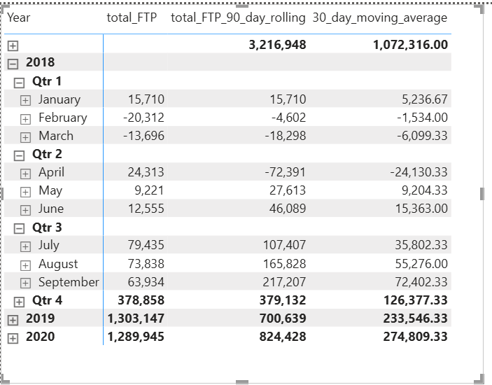
Now, ab jab profit nikalna ho hr month ka, ya just revenue generate krna ho to hm just total_ftp hi nhi len gy bal k hm 90-day-rolling-value and 30-day-moving-average bhi saath len gy,, revenue k liye filter m sales daal den gy ya meadure calculate kr len gy, calculate (30_day_moving-average, sales), yani jab filter sales tha to moving average and rolling value do
Calculating 3 month rolling value and 1 month moving average:
90 days are not always equal to 3 months as feb m just 28 days hoty and agr hm April ki value dekhna chahy to 90 days s value 30th jan s start hon gi calculate hona, and we want k just hr month ka hi ho bs, yani April ki baat kryn to feb ka full month, march ka full month and April ka full month
total_FTP_3_month_rolling = CALCULATE([total_FTP], DATESINPERIOD( 'Calendar'[Date], [max_date], -3, MONTH))
yani max date s 3 months peachy
total_FTP_monthly_moving_average = [total_FTP_3_month_rolling]/3
yani on average: hr month m kitna hua
hm y values (i.e: 3 months rolling value, 1 month moving average value, 90 days rolling value, 30 days moving average ) kisi bhi parameter k saath get kr skty h, e.g: it can be for sales, for operating expenses , non-operating etc etc
-----------------------
Calxulating averge value for balance sheet
We will valculate average value for balance sheet usong 2 ways, 1st way is to get the average value of the “starting value of the month (opening balance) and the last value present in the account at the last day of the month”, the tab for it in is “TTD_average value” the measures are mentioned in the calender table for this.
2nd way is to calculate the average for each day, we want closing balance for every single day and then sum up all the values and divide it with the number of days, we cannot use simple average function because simple average will sumup all the transactions happned at that day and then divide all the values with the total number of transactions, but we want answer for days instead of transcations.
Yani hr din kitna closing balance tha hmary pas, un saari values ko + kr k then total number of days pr divide kr dena h
NOW TO ACHIEVE THIS: we will use averagex because sab s phly hmy ek virtual table bnana h using summarize because GL k andr hmary pas hr day pr kitna total_balance h, y nhi mojood bal k GL k pas total transactions hn, yani +5 ki transaction hui jan 1 pr then again -2 ki trabnsaction dubara hui jan 1 pr and so on, sab s phly hmy hr day pr closing balance lena h and for this we will use summarise function and SUMMARIZE(Calendar, Calendar[Date])
creates:
Date
1 Jan
2 Jan
3 Jan
Then hm n [total_to_date] ko use kia ta k hmy hr date pr closing balance mily then we calcuylated average of all these balances using avergagex
Section 12:Calculating dynamic period on period growth:
Yani hmy y baat check krni h k hr month, hr quarter ya hr year pr kitni growth hui previous month, quarter ya year s respectively,, e.g: in January end hmary pas balance tha 1000$ and feb k end pr hmary pas balance tha 2000$, so we wanna check k hmary pas sirf Feb k month m kitna balance generate hua, yani jan m just 1000$ and feb m 2000$ jan and feb dono ka mila kr h, sirf feb ka get krny k liye hm fdeb m s jan ka balance minus kryn gy, yani feb ka opening balance is actually the closing balance of jan, we wil 1st calculate the opening balance if feb (opening balance = TTD – FTP), and then is opening balance of feb m s minus kryn gy feb ka closing balance which is 2000$ in this case,, so growth in feb = closing balance – opening balance (2000 – 1000 = 1000$),, if we wanna get the percentage , we use formula (closing – opening)/opening, OR (current value – previous value)/previous value ,, yani current value jo is time account m h which also include some amount from previous month and previous value is actually the value from the previous month or we can also say it as the opening value for this month and divide it with previous value because percentage k liye hm y dekhty hn k hm n kis value k muqably m amount ka change dekhna h, yani hm chahty hn k previous month ki amount k muqably m kitna change ay ga growth m is liye previous s divide kr dia THIS WAY IS FOR TTD, balance sheet
We have used this formula: period_on_period_growth = IFERROR(([total_to_date]-[TTD_Previous_period])/[TTD_Previous_period], "")
IFERROR is liye likha q k jan k case m previous value 0 thi, to “current value – 0 / 0” cause inficity so we use ifferror that agr khi error aya to “” s replace kr dena yani emptly s replace kr dena
opening balance = TTD – FTP???? Y formula kesy bna? FTP is actually all the trtansactions of a specific period,, closing balance = opening balance + transactions, and we rearrange this as: opening balance = closing balance – transactions
Growth for each month, quaretr etc etc is calculated differently for both balance sheet and p and L.
Now we talk about FTP:
phly TTD m hmary pas jo value ek specific month pr show ho rhi vo value actually us specific month ki amount and us s phly jitni months guzry un sab ki amount ka sum tha, phir hm n us specific month ki apni value get ki jis k liye hm n us month ki opening value ko minus kr dia closing value s , opening value actually previous month ki closing value thi, is s hmy us soecific month ka apna bakance mil gya and hm n growth calculate kr li
but here if we already have the amount for each month, e.g: FTP amount, to calculate the growth, we will first calculate the amount from the previous month and for this, we will use 2 measures,
totalFTP_previous_value_of_period = CALCULATE([total_FTP], DATEADD('Calendar'[Date], -1, MONTH))
is measure s hm just ek month peachy chly jayn gy, y months ki previous value hget krny k liye to theek h, lekin quarter ki previous value k liye hmy 3 months pichli value chahye and year ki previous value k liye hmy 12 months previous value chahye, is k liye hm n jhan -1 likha h vhna kuch esa ho k agr hm year pr jayn to automatically 12 likha a jay, jab hm quarter pr jayn to 3 likha a jay, is liye we will use measure
no_of_month = DISTINCTCOUNT('Calendar'[Month])
totalFTP_previous_value_of_period = CALCULATE([total_FTP], DATEADD('Calendar'[Date], - no_of_month, MONTH))
-[no_of_month], yani itny months peachy jao jitni value y measure show kry ga
Then growth get krny k liye,
(total_ftp - totalFTP_previous_value_of_period)/ totalFTP_previous_value_of_period
Is s percentage growth a jay gi,,,, we can apply filter and check growth on each level, on selecting sales to revenue growth per period, or on net profit by not selecting any thing , just selecting profit and loss etc and so on
Section 13:Horizontal analysis of financial staements:
For p and L/income statement:
So in horizontal analysis, we prepare year to year growth for each element of income statement, that
is sales, cost of sales, marketing expenses, rent or whatever is appearing on the income statement.
So you prepare the report in such a way that you can analyze the growth in each item of the PNL from
year to year, or you can say quarter to quarter or you can say month to month, and then you can pick
up the values where the growth is not consistent with the top line sales growth.
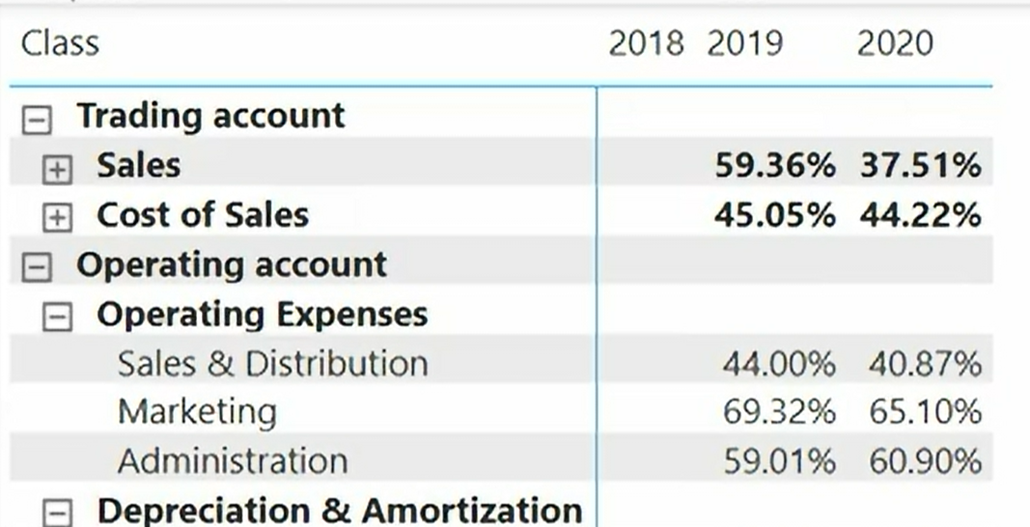
Ab yhna dekha ja skta h k 2019 and 2020 k sales and cost of sales ka trend opposite h, 2019 m sales to 59% brhi compared to previous year but cost of sales just 45%, hala k sales k increase hony s cost of sales increase hoti h,yhan trend may be is liye aya k hm n cost controls ki apni, ya hm n product ki quality km kr di yani us ko bnany ki cost km kr di
For balance sheet:
Similarly we create horizontal analysis for each element for balance sheet and compare the growth, just like p and l
Section 14:Vertical analysis of financial statements:
Out of the total sales revenue, how much percentage was spent on each expense?
FOR P AND L:
e.g: if we have revenue of 10,000$, we spend 2000$ on marketing, 200$ on administration etc , then marketing will take 2000/10,000 = 20% of the sales revenue , similarly, administration bhi koi specific percentage of amount le ga revenue s, although y expenses hm phkly krty hn or sales revenue baad m generate hota h but hm compare krty hn hr chees ko sales revenue s the main source of money for the company
so if we use this: sales_revenue = CALCULATE(SUM(GL[Amount]), 'Chart of Accounts'[SubClass] = "Sales") and then : vertical_analysis = (([total_FTP])/[sales_revenue])
Y hmy almost hr jga infinity de ga sivay un un jgho pr jha jha chart of account m sales ho ga
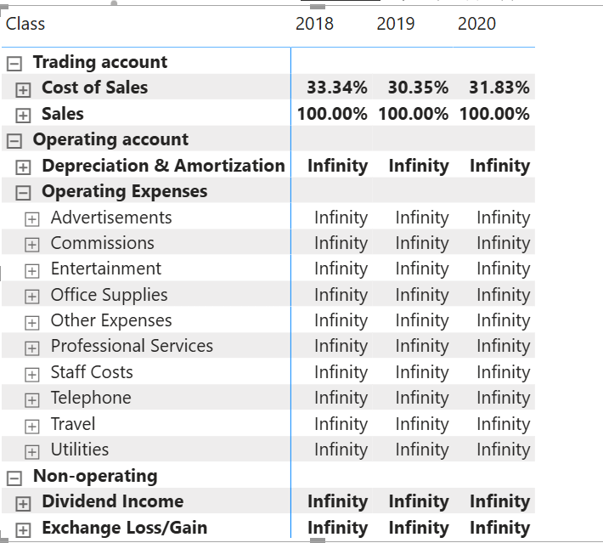 q k hm n y likha hua h k jab jab hmary pas subclass “sales” ho ga bs tab tab hi amount ka sum kro, lekin jab jab hmary pas subclass marketing etc hua to amunt ka sum 0 a gya and is vja s total_ftp ko 0 s divide krny s infinity aya,,, we will change the measure little bit and write that remove all filter, total_sales_bypass_COA_filters = CALCULATE([sales_revenue], ALL('Chart of Accounts'))
vertical_analysis = [total_FTP]/[total_sales_bypass_COA_filters]
actually 2 filters lag rhy hn, ek vo filter jo hm sales revenue m daala k just vo amount do jab sublcass sales ho, and dusra vo filter jo power BI khud lga rhi, k just vo amoount sales sublcass k agy hi show ho gi, sab sublcass marketing ya kuch or ho ga to amount show nhi ho gi, ham is filter ko remove kr rhy hn ALL() k zrye k subclass chahy jo bhi ho, sales ki amount hr subclass k element k agy show ho
By turning ON rowsubtotals from this matrix, you can also get net profit margin ., gross profit margin etc etc
For balance sheet:
Just like p and l, we will calculate on the basis of assets hjere, yani assets ki 100% m s hr hr element jo balance sheet k andr h vo assets ka kitna percent h
Section 15:Calculating previous corresponding period and PCP growth:
This is previous corresponding period, yani agr sepetmeber 2020 h to is ka PCP September 2019 ho ga and is sep 2019 ka PCP sepetmber2018 ho ga,, yani previous period jo k corresponding bhi ho us ka, phly hm PCP ki value get krty hn and then growth dekhty hn
Is k liye power BI k apny andr ek function h which is sameperiodlastyear:
total_FTP_PCP = CALCULATE([total_FTP], SAMEPERIODLASTYEAR('Calendar'[Date]))
And then we calc calculategrowth easily:
totalFTP_PCP_Growth = IFERROR(([total_FTP]-[total_FTP_PCP])/[total_FTP_PCP],"")
for TTD PCP values:
almost the same formulas just like FTP, just wioth little bit changes, the formulas are mentioned in the file
Section 16:Cash flow statement:
Learn some concepts first:
- Profit ≠ Cash, because sometimes a company generates profit but does not receive that profit in cash immediately.
For example: a company sells products to a customer on credit. The Income Statement will include those sales in revenue and profit, but in reality the company has not yet received the cash. Therefore, this increase in receivables means cash has not been received yet, so in the operating section of the Cash Flow Statement we subtract the increase in receivables.
Similarly, there may be some bills or expenses that the company has recorded but has not yet paid. These expenses reduce profit in the income statement, but the cash has not yet gone out of the company, so an increase in payables is added back in the cash flow statement because the cash has not left yet.

- Cash flow statement bnaty huy just remember 2 questions:

  - Did this reduce/increase profit but no cash actually moved?
If something changed profit but no cash actually moved, then we adjust it.
For example, depreciation reduces profit but does not involve any cash payment in the current period, so we add it back when starting from profit (indirect method).
Also, if profit increased because of credit sales (increase in receivables), then cash has not been received yet, so we subtract that increase from profit in the operating section.
  - Did this affect profit but it actually belongs to another cash flow section?
Sometimes an item affects profit but actually belongs to another section of the Cash Flow Statement.
The three sections are:
- Cash Flow from Operating Activities
- Cash Flow from Investing Activities
- Cash Flow from Financing Activities
For example, when we prepare the operating section using the indirect method, we start with Profit Before Tax from the Income Statement.
But this profit includes non-operating items, such as:
- dividend income
- interest income
- gain or loss on sale of assets
Since these items do not belong to operating activities, we remove them from the operating section.
For example, if dividend income increased profit, we subtract it from the operating section, because it will appear in the investing activities section of the Cash Flow Statement.
So the rule is:
If something affects profit but belongs to another cash flow category, we remove it from this section and it will appear in its correct section (investing or financing).
P and l or balance sheet ka structure already hmary pas tha, q k chart of account asl m chart of accounts ka role bhi play kr rha tha or p and L and balance sheet ka structure bhi de rha tha, but cash flow statement k structure k liye file cashflow_ST k name s h, easyyyyy, agr y structure valiu file na hoti to it takes a lootttt of time to generate a structure first
--------------------------------------------------------------------------------------------------------------------------------------------
Cashflow from operating activities, from investing activities and from financing activities are three different types of flows in cash flow statement,, e.g: we have to start a business, we need money to start that business( financing activities),, this money will be invested because hmy kuch fix assets ki investment chahye such as shop or buiding, machinery, inventory etc (investing activities) and phir business k saary operations a gay such as administration ko handle krna, marketing krna etc etc ,, yani 1st we need finance then investment and then we can start operational activities
- ab finance kha kha s a skta h, yani pesa kha kha s le skty hn to strat a business: it can be from shares, loan or be debentures (long-term loans almost),,
---> issuance of share (+)
---> loan (+)
---> redemtion of debenture (-)
---> loan paid (-)
---> interest paid * (-) #jo loan k pesy th vo vapis krty huy jo interest dia vo bhi isi finanacial k under hi ay ga,, jhan gaayn jay gi vhi bachra bhi jay ga
---> dividend paid * (-) # A dividend is simply a part of a company’s profit that is given to its shareholders.
* is liye lgaya q k in 2 ka 2nd effect bhi h jo agyu discuss ho ga
ab cash flow from investing activities m kia kia ay ga: is m FIX ASSETS s cash ka movement and other INVESTMENTS ayn gi
---> purchase of fix assets and investment (-) # pesa km ho ga is liye minus
---> sale of fix assets / investment (+)
---> dividend received (+) # ab jb investment ki to dividend receive ho ga or is ko bhi hm isi portion m likhyn gy q k jhan gayn vha bachra bhi, jesy finance valy m loan lia tha to loan paid and us loan pr interest paid bhi vhi likha tha, isi trah yhan pr investment ki to us investment pr jo dividend mila vo bhi vhi and simiularly agr kisi bond etc m investement kr do to us investment pr jo interest mila vo bhi vhi likhyn gy,, finance m interest paid and dividend paid tha, lekin yhan pr interest received and dividednt received ay ga
---> interest received (+)
---> rent received (+)

- ab is k ilava jo kuch bhio reh gya vo operating activities m jay ga,, jo jo current assets and current liabiulites k changes hon gy vo operating activities m jayn gy,, cash flow from operational activities can be calculated from 2 ways: direct method and indirect method,,
--- DIRECT METHOD:seedha seedha method h, but y hr jga use nhi ho skta h q k is k liye hmy P and L statement chahye , e.g:
Sales (+)
Cost of goods sold (-)
Salary (-)
Advertisement (-)
Marketing (-) etc etc
-- INDIRECT METHOD: y hr trah k question ko solve kr skta h

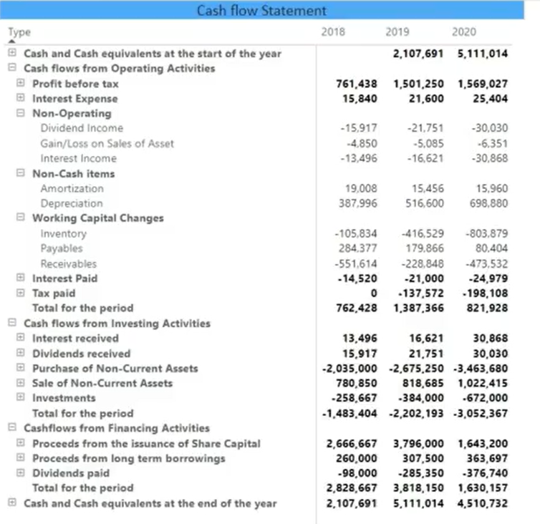
- Investing and finance vala uoer sara explain ho gya h,, operating expenses valy m dekho kn: interest expense is (+) q k y operating activities ka part nhi h, hm n just operating activities s jo cash upper neechy hua vo dekhna h or net profit m s already interest expense deduct hua hua tha, ab agr operating activities m jo final cash ki amount ai us m interest expense already nikla hua h to hm y nhi keh skty k y amount just operating activities s mili h, is liye hm n net profit ki amount m interest expense ko vapis add kr dia, ta k solely cash flow from operating activities pr kaam kia ja sky
- Non-operating valy saary (-) hn q k hm n just operating pr kaam krna h, same upr vala concept
- Non-cash items ki baat krty hn to depreciation and amortisation operating expenses m shamil hota h and P AND L s jo net profit nikalta h us m s hm n y amount already deduct ki hoti h but in reality this amount is never paid because it is just accounting adjustment, yani is amount ka cash abhi tk hmari company s baher nhi nikla , is liye hm n y amount vapis add kr di
- Interets paid and tax paid (-) hn q k y pesy hm n nikaly hn company s

Ab peachy reh gya k lecture m all-ftp, all-ftp-cs etc etc kesy kesy likha hm n
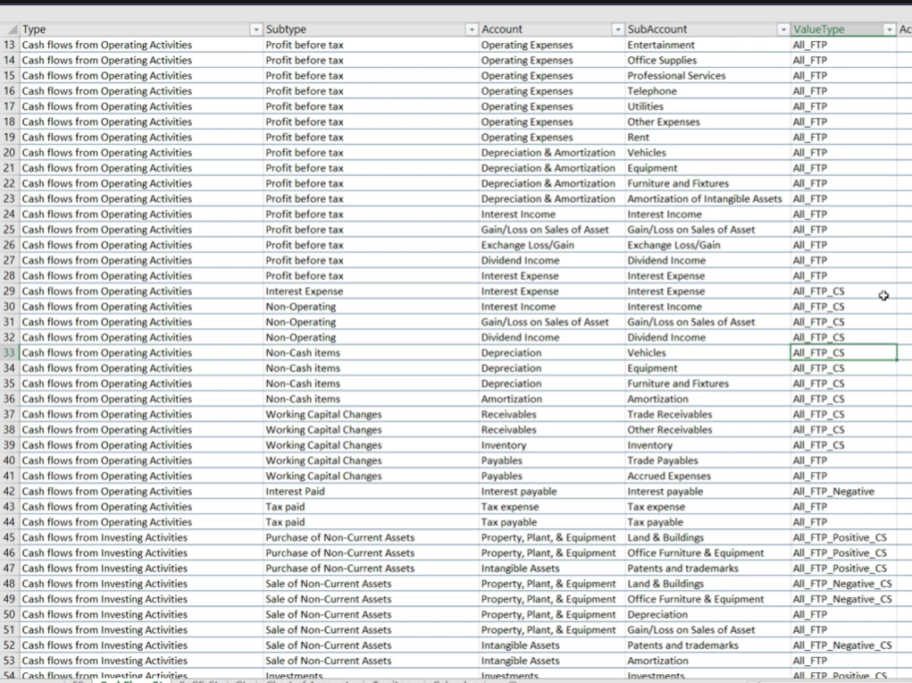
- PROFIT BEFORE TAX m sab k agy all_ftp q k y hm ek qism ki P AND L statement calculate kr rhy phly, is liye saaro ki amount ko add kr dena h , jis amount k saath (-) sign tha (GL k andr of course) vo automatically handle ho jay gi
- Interest expense account key 440 h, is m GL m jo amount likhi h vo already -ve h, ab hmy cash flow from operating expenses m interest expense ko add krna h, to is liye all-ftp yani interest expense ki amount ko total kro and y amount -ve sign k saath ay gi but hmy to cash flow statement dekhaty huy is amount ko add krna h is liye change sign krna h saath, same is the concept with non-operating, non-cahs and others
- Interest paid m all-ftp-negative ka matlab y h k interest expense ledger ki just negative values ko uthana h, yani interest expense ledger m jab jab amount -ve h, q k hmari GL esy hi show kr rhi h k jo jo amount pay kr di vo -ve h or jo jo amount pay krni h vo positive h, ab interest paid yani interest pay kr dia , is liye amount -ve h or just isi negative amount ko hi uthana h,, ledger interest expense h is ka hmy esy pt alga q k interets paid pr jo account key use ho rhi h vo 121 h or GL table m 121 account key pr interest expense mention h,,,,, yani negative amount ka matlab h credit, becuse credit ko -ve s mention kia gya h, amount pay nhi ki yani abhi liability h, to liability vali amount uthani h, yani credit vali amounts uthani hn just
- Purchase of non-current assets m ALL-FTP-positive-CS is liye lia q k purchase of non-current assets m hmy purchase k saath saath disposals bhi given hn, hmy disposals (removal of assets) jo k negative sign k saath mention hn vo nikaal deny hn, hmy just purchases ki amount ko sum krna h and purchase + k saath mention h,, hmary GL k amount column m credit debit k according signs change ho rhy hn, jesy k assets ka purchase yani asset ka increase debit h and debit is mentioned by +ve sign,,, acha kher positive valy utha leny hn or y cashflow m -ve value ho gi q k purchase m pesy nikal gay is liye sign change kia hm n
- Isi trah sale of non-current assets actually disposal hua, yani asset km ho rha h, asset ki kmi credit h and credit is mentioned by -ve sign here, is liye us ledger m s negative valy uthay just
- Ab agy investment all-ftp-positive-cs, q k investment yani assets ka increase/cash ki kmi, yani debit , yani +ve , ab sign change is liye q k cash baher nikla cash flow m

Section 17: Statement of changes in equity:
Equity simply means ownership(shares) of a person in a company, yani person company ka koi share buy kr leta h jo k equity kehlata h and at the end, us person ko us k shares yani equity ki base pr profit milta h,, agr kisi person n koi investment nhi li kisi person s to 100% equity yani 100% company usi founder ki hi ho gi jis n company start ki and agr us n koi share becha and kisi n le lia to profit distribute ho jay ga, yani dono ko apni apni equity k according profit mily ga
e.g: in shark tank: a person ask for 50 lac rupees for 2% equity, but sharks want to offer 50 lac rupees for 5% equity

